Test Case: runTestMultipleTimes
Step 1 - Enter username and password and click to button Enter : Credentials Entered
Image file-name: QC_Testing-runTestMultipleTimes-dic. 03 2025, 09 28 42 a. m.

Image file-name: QC_Testing-runTestMultipleTimes-dic. 03 2025, 09 28 43 a. m.

Step 2 - Select to UEN and Access to Administrador Roles Menu: UEN Correctly selected and Correct access
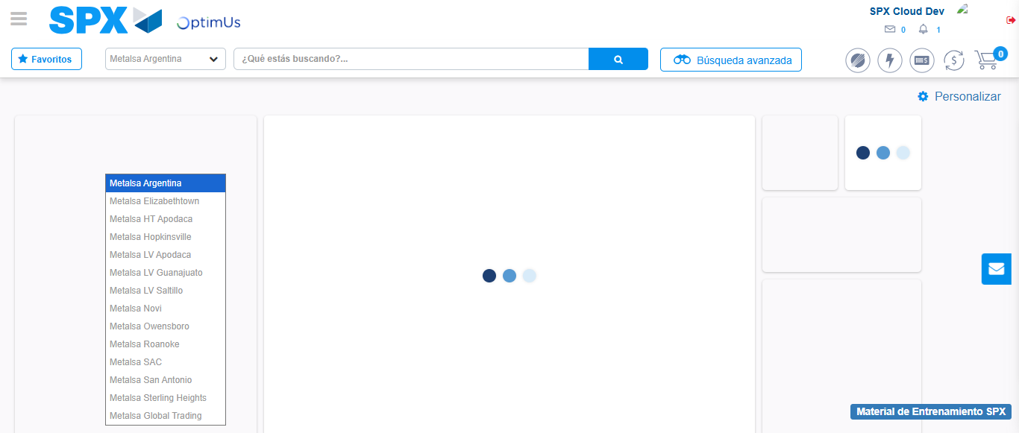Image file-name: QC_Testing-runTestMultipleTimes-dic. 03 2025, 09 28 46 a. m.

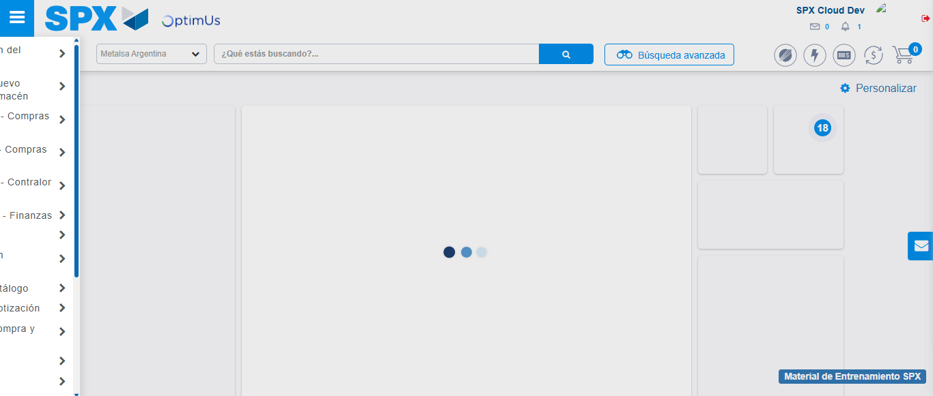Image file-name: QC_Testing-runTestMultipleTimes-dic. 03 2025, 09 28 47 a. m.

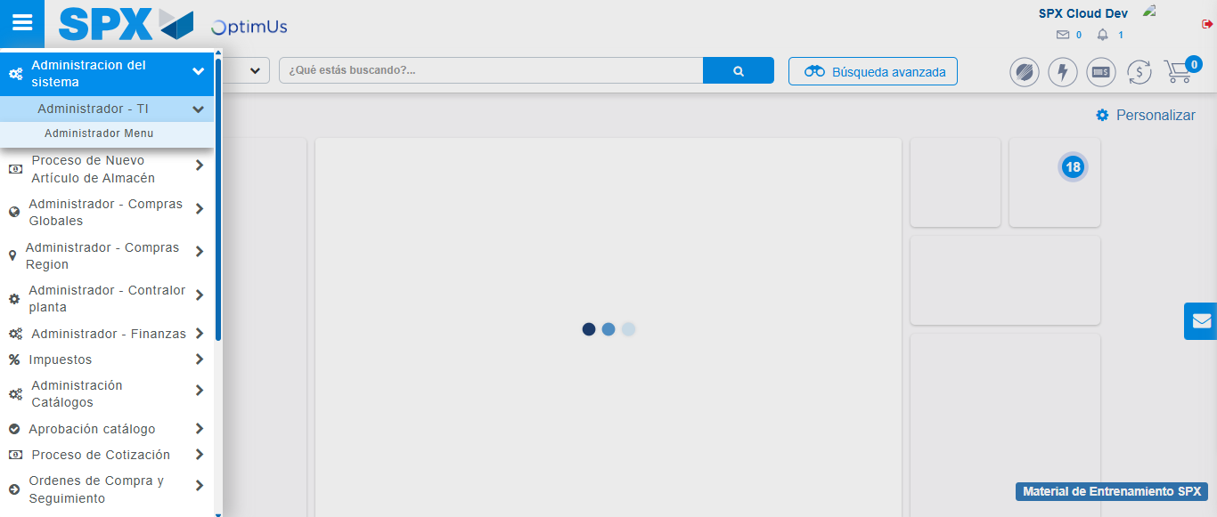Image file-name: QC_Testing-runTestMultipleTimes-dic. 03 2025, 09 28 48 a. m.

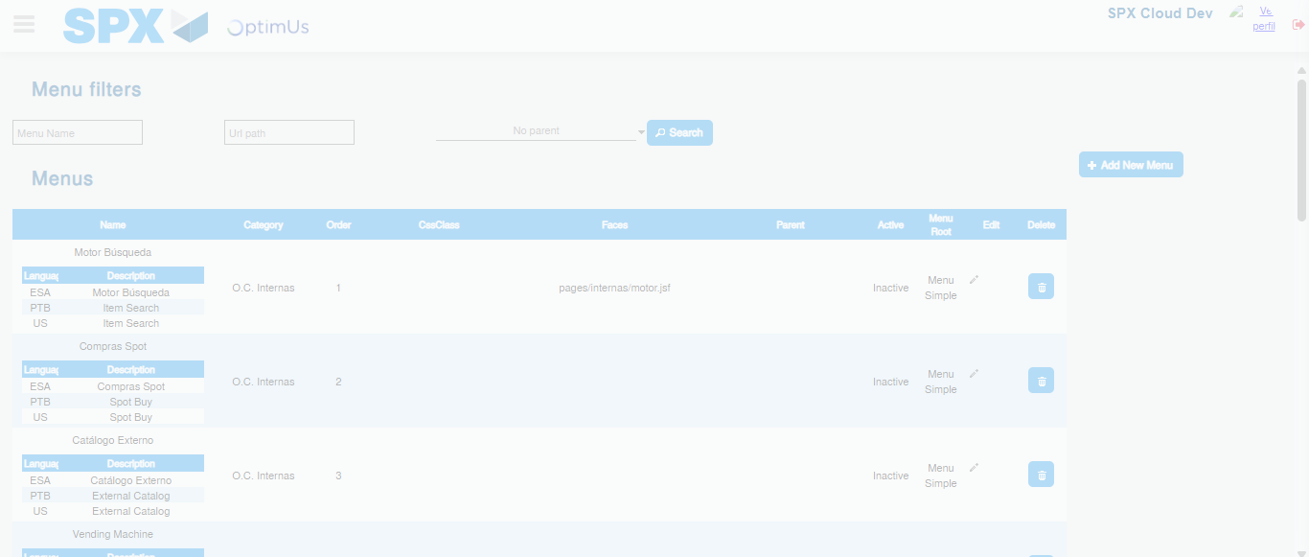Image file-name: QC_Testing-runTestMultipleTimes-dic. 03 2025, 09 28 54 a. m.

Step 3 - Add new menu and edit fields: New menu successfully registered
Image file-name: QC_Testing-runTestMultipleTimes-dic. 03 2025, 09 28 54 a. m.

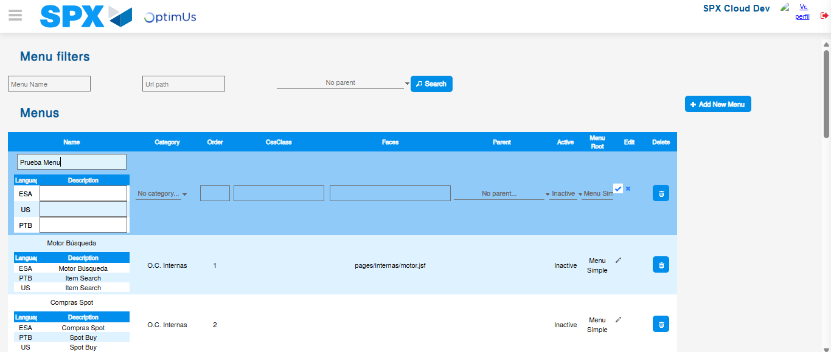Image file-name: QC_Testing-runTestMultipleTimes-dic. 03 2025, 09 28 58 a. m.

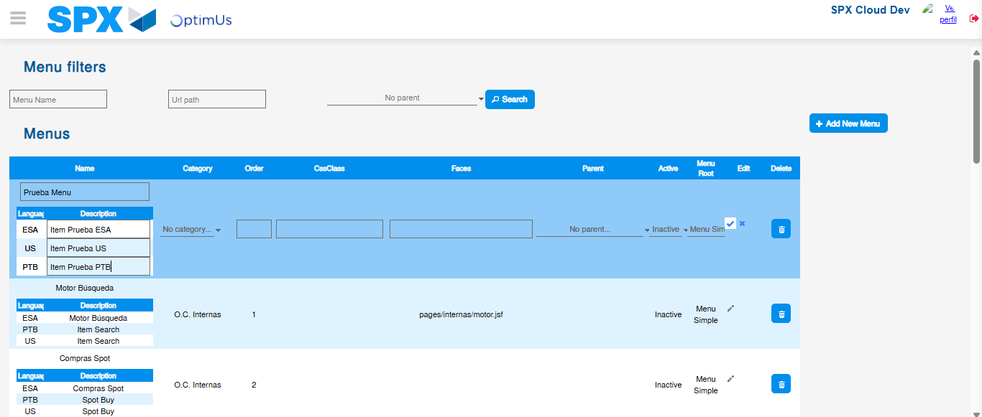Image file-name: QC_Testing-runTestMultipleTimes-dic. 03 2025, 09 28 59 a. m.

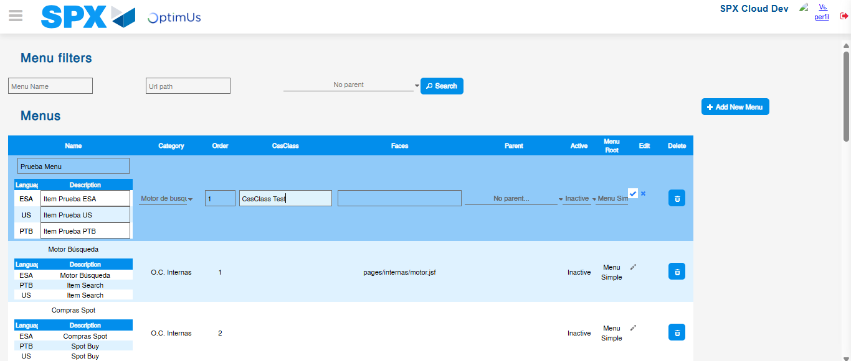Image file-name: QC_Testing-runTestMultipleTimes-dic. 03 2025, 09 29 00 a. m.

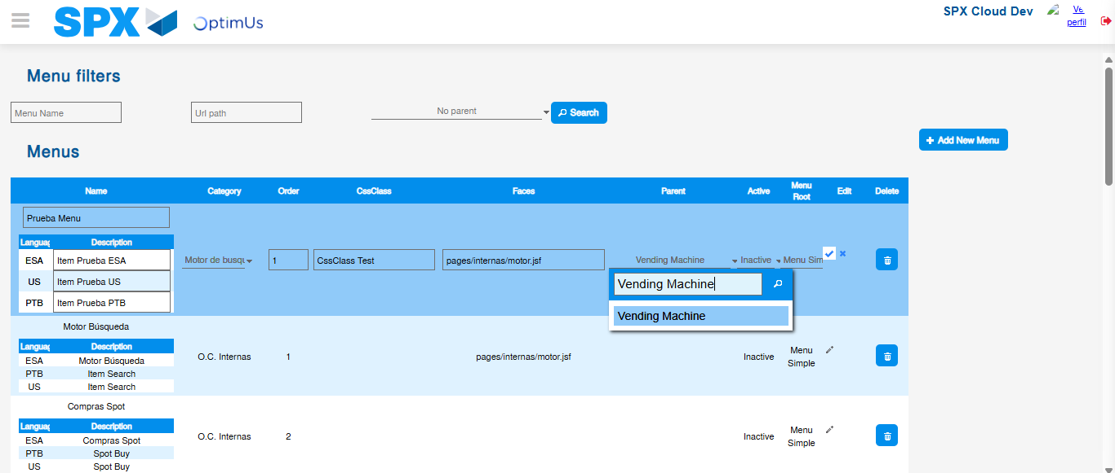Image file-name: QC_Testing-runTestMultipleTimes-dic. 03 2025, 09 29 01 a. m.

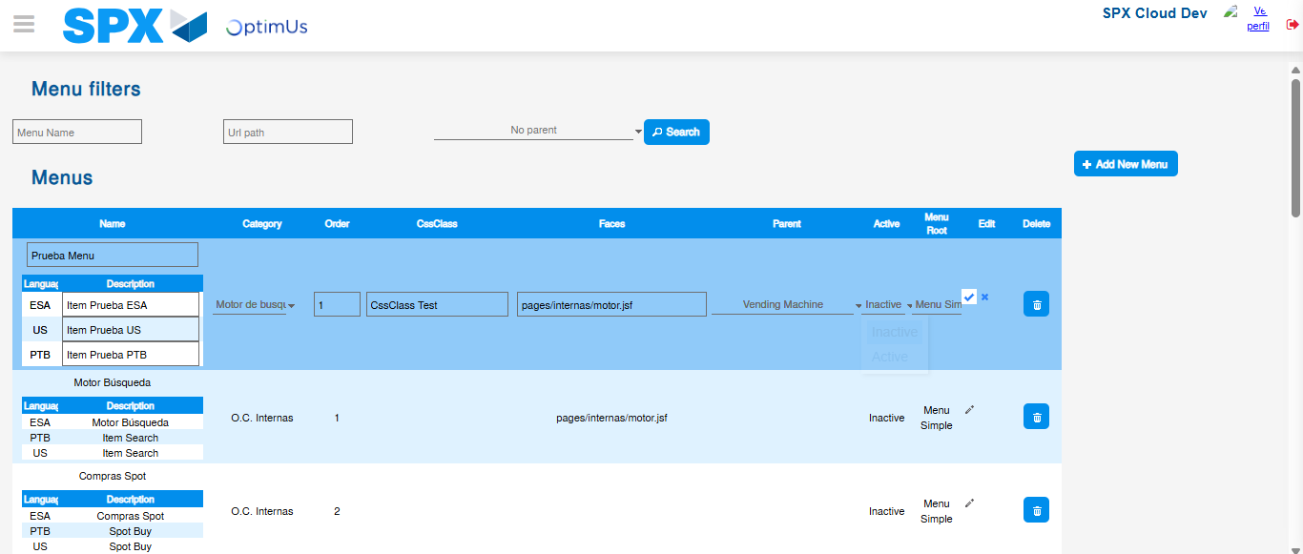Image file-name: QC_Testing-runTestMultipleTimes-dic. 03 2025, 09 29 02 a. m.

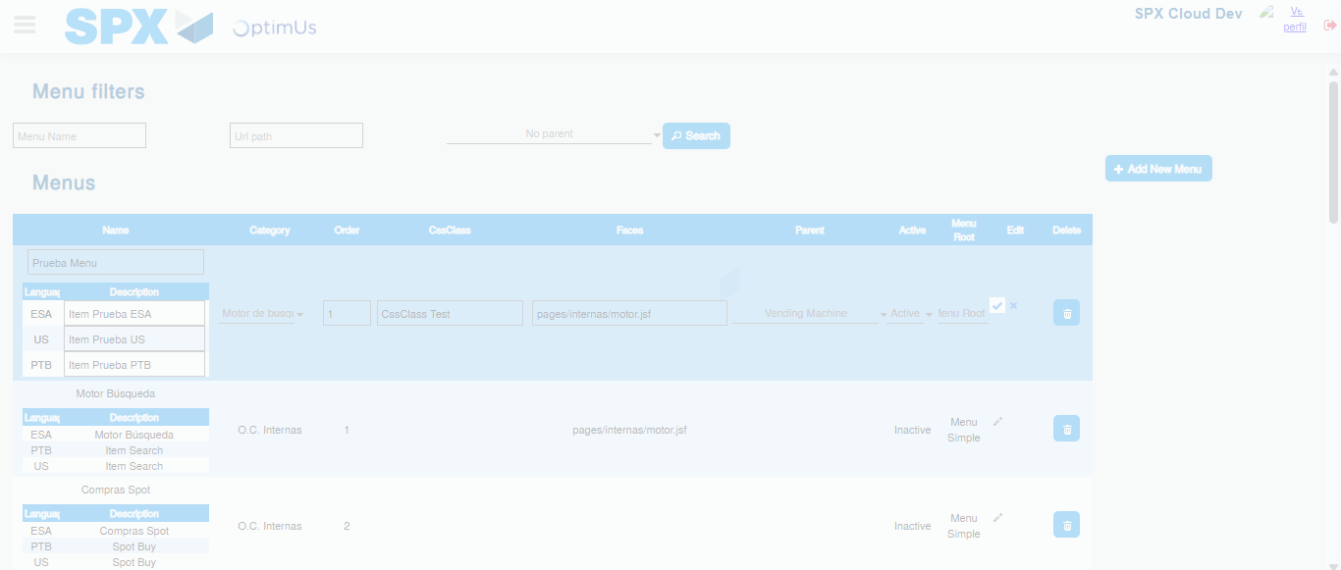Image file-name: QC_Testing-runTestMultipleTimes-dic. 03 2025, 09 29 03 a. m.

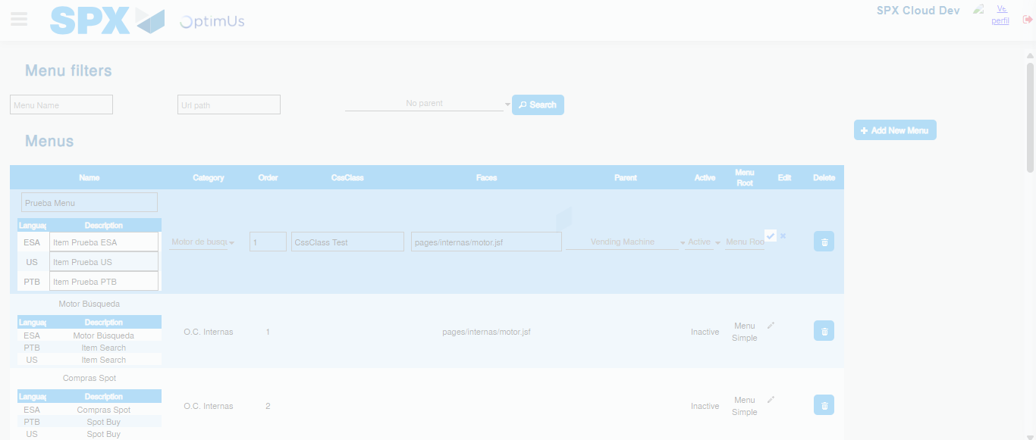Image file-name: QC_Testing-runTestMultipleTimes-dic. 03 2025, 09 29 04 a. m.

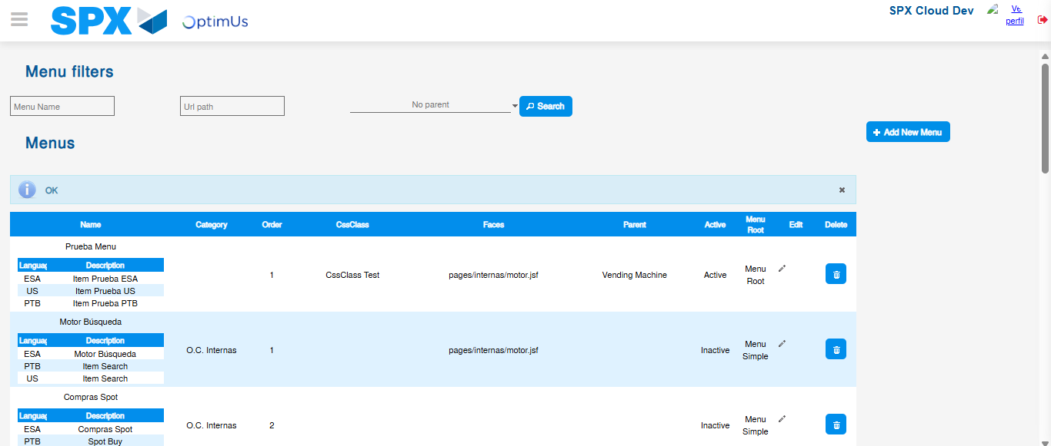Image file-name: QC_Testing-runTestMultipleTimes-dic. 03 2025, 09 29 07 a. m.

